**Standard Operating Procedure**

**Grinding and Drilling Preparation**



**ODISHA MINING CORPORATION LTD.**

**KODINGAMALI BAUXITE MINE**

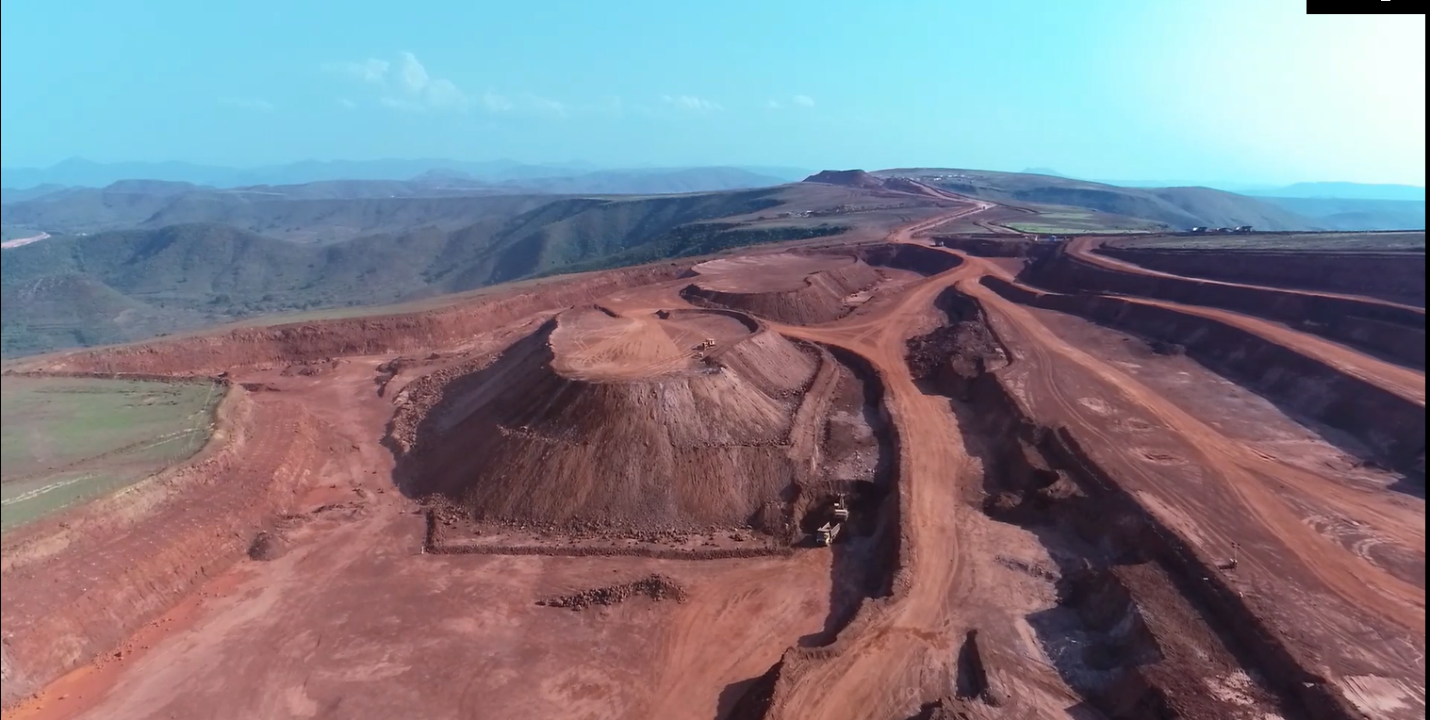

**Authorized By**

**Procedure:**

1. Only authorized personnel are allowed to work in the machine.
2. Ensure that all required PPE is in good condition and correctly fitted.
3. Ensure that the area around the grinding process is clear of people. Remember that a stream of sparks from an angle grinder can travel many meters and cause injury to a third party. Where possible use welding screens to contain the sparks.
4. Check the external surfaces of the tool including the power cable and plug to ensure there are no breaks or defects. Any defective equipment should be tagged out of service and repaired before it is used again.
5. Check the Electrical Safety Test Tag to ensure the equipment has been tested and is in date. If the tool is out of test, it should not be used and tagged out of service until the next testing period.
6. Ensure you have a firm grip of the grinder with both hands as it will kick at start-up. Angle grinders should never be used with one hand.
7. Switch on the grinder and allow it to run up to full speed before you start grinding.
8. While grinding, do not force the wheel onto the work as this will cause the wheel to dig-in and may result in kick-back.
9. Ensure the disk has completely stopped before putting the grinder down